LIGHTHOUSE

Lighthouse is an open-source, automated tool for improving the quality of web pages. You can run it against any web page, public or requiring authentication.

It has audits for performance, accessibility, progressive web apps, SEO and more.

Add Lighthouse extension to chrome

To install the extension:

1. Download [Google Chrome for Desktop](https://www.google.com/chrome/browser/desktop/).
2. Install the [Lighthouse Chrome Extension](https://chrome.google.com/webstore/detail/lighthouse/blipmdconlkpinefehnmjammfjpmpbjk) from the Chrome Webstore.

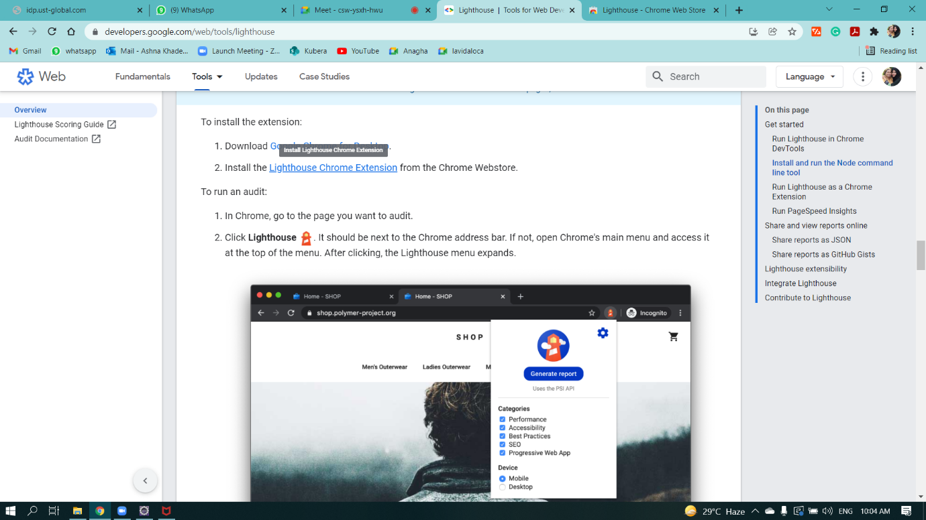

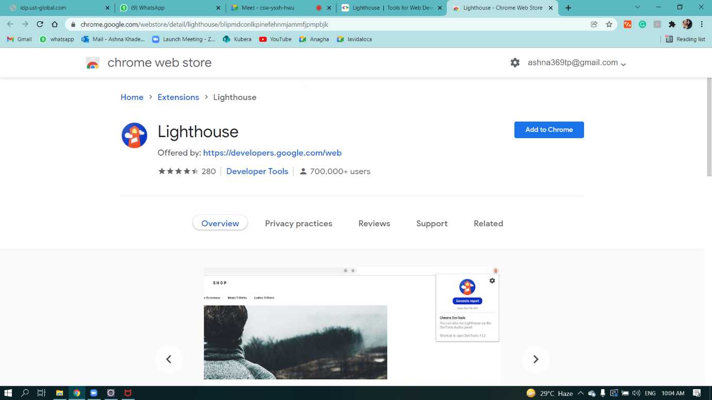

Quality assessment of Urban Ladder Website:

To run an audit:

1. In Chrome, go to the page you want to audit.
2. Click **Lighthouse** Lighthousefrom inspect section of the corresponding website.

